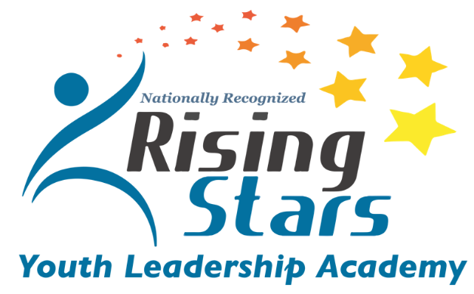

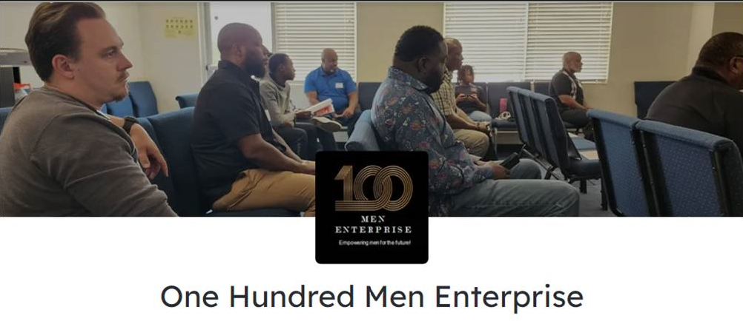
East Region Winter Quarter Schedule Martin Luther King Community Center
Date | Time | Location | Leadership Development Topic
Tuesday  January 16, 2024 | 6:30 -8:00 pm | MLK CC  5565 Truman Dr.  Fort Worth 76112 | 619 Productions  Theater Basics:  Stage Direction  Team Grouping for Skits
Tuesday  January 23, 2024 | 6:30 -8:00 pm | MLK CC  5565 Truman Dr.  Fort Worth 76112 | 619 Productions  Acting Exercises:  Warm-ups & Table Read  Casting for Acting Roles
Tuesday  January 30, 2024 | 6:30 -8:00 pm | MLK CC  5565 Truman Dr.  Fort Worth 76112 | 619 Productions  Acting Exercises:  Warm-ups  Skit practice  Props and costumes
Tuesday  February 6, 2024 | 6:30 -8:00 pm | MLK CC  5565 Truman Dr.  Fort Worth 76112 | 619 Productions  Theater Presentation:  Final Skit Performance  Presentation Awards
Tuesday  February 13, 2024 | 6:30 -8:00 pm | MLK CC  5565 Truman Dr.  Fort Worth 76112 | David Howard Urban Village Family Services  Financial Development Series Part I
Saturday  February 17, 2024 | 9 am-  3 pm | YMCA Camp Carter  6200 Sand Springs Rd.  Fort Worth 76114 | Group 1 Ceramics  Group 2 Zip Line  Lunch  Group 2 Ceramics  Group 1 Zip Line
Tuesday  February 20, 2024 | 6:30 -8:00 pm | MLK CC  5565 Truman Dr.  Fort Worth 76112 | David Howard Urban Village Family Services  Financial Development Series Part II
Tuesday  February 27, 2024 | 6:30 -8:00 pm | MLK CC  5565 Truman Dr.  Fort Worth 76112 | David Howard Urban Village Family Services  Financial Development Series Part III

East Region Winter Quarter Schedule Martin Luther King Community Center
Tuesday  March 5, 2024 | 6:30 -8:00 pm | MLK CC  5565 Truman Dr.  Fort Worth 76112 | 100 Men Enterprise  Resolving Conflict

North Region Winter Quarter North Tri Ethnic Community Center
Date | Time | Location | Leadership Development Topic
Tuesday  January 16, 2024 | 6:30 -8:00 pm | North Tri Ethnic CC  2950 Roosevelt Ave.  Fort Worth 76106 | 100 Men Enterprise  Resolving Conflict
Tuesday  January 23, 2024 | 6:30 -8:00 pm | North Tri Ethnic CC  2950 Roosevelt Ave.  Fort Worth 76106 | Lontage Woods  New Focus Family and Youth Consulting  Topic: Decision Making  - Teen Behavior-Problem Solving
Tuesday  January 30, 2024 | 6:30 -8:00 pm | North Tri Ethnic CC  2950 Roosevelt Ave.  Fort Worth 76106 | Lontage Woods  New Focus Family and Youth Consulting  Topic: Decision Making  - How to Deal with Peer Pressure
Tuesday  February 6, 2024 | 6:30 -8:00 pm | North Tri Ethnic CC  2950 Roosevelt Ave.  Fort Worth 76106 | Lontage Woods  New Focus Family and Youth Consulting  Topic: Decision Making  - Mental Health and Weighing Your Decision-Making Options
Tuesday  February 13, 2024 | 6:30 -8:00 pm | North Tri Ethnic CC  2950 Roosevelt Ave.  Fort Worth 76106 | JR Holguin  Success Mind Shift  Sometimes you Win, Sometimes Your Learn for Young Leaders  Lesson 1 topics:  - When you’re losing, everything hurts  - Humility; The spirit of learning  - Reality: the foundation of learning  - Responsibility: The first step of learning
Saturday  February 17, 2024 | 9 am-3 pm | YMCA Camp Carter  6200 Sand Springs Rd  Fort Worth 76114 | Group 1 Ceramics  Group 2 Zip Line  Lunch  Group 2 Ceramics  Group 1 Zip Line
Tuesday  February 20, 2024 | 6:30 -8:00 pm | North Tri Ethnic CC  2950 Roosevelt Ave.  Fort Worth 76106 | JR Holguin  Success Mind Shift  Sometimes you Win, Sometimes Your Learn for Young Leaders  Lesson 2 topics:  - Improvement: The focus of learning  - Hope: The motivation of learning  - Teachability: The pathway of learning
Tuesday  February 27, 2024 | 6:30 -8:00 pm | North Tri Ethnic CC  2950 Roosevelt Ave.  Fort Worth 76106 | JR Holguin  Success Mind Shift  Sometimes you Win, Sometimes Your Learn for Young Leaders  Lesson 3 topics:  Adversity: The Catalyst for learning  - Problems: Opportunities for learning  - Bad Experiences: The perspective for learning
Tuesday  March 5, 2024 | 6:30 -8:00 pm | North Tri Ethnic CC  2950 Roosevelt Ave.  Fort Worth 76106 | JR Holguin  Success Mind Shift  Sometimes you Win, Sometimes Your Learn for Young Leaders  Lesson 4 topics:  - Change: The price of learning  - Maturity: The value of learning  - Winning isn’t Everything, but Learning is

West Region Winter Quarter Thomas Place Community Center
Date | Time | Location | Leadership Development Topic
Thursday  January 18, 2024 | 6-7:30 pm | Thomas Place CC  4237 Lafayette Ave.  Fort Worth 76107 | 619 Productions  Theater Basics:  Stage Direction  Team Grouping for Skits
Thursday  January 25, 2024 | 6-7:30 pm | Thomas Place CC  4237 Lafayette Ave.  Fort Worth 76107 | 619 Productions  Acting Exercises:  Warm-ups & Table Read  Casting for Acting Roles
Thursday  February 1, 2024 | 6-7:30 pm | Thomas Place CC  4237 Lafayette Ave.  Fort Worth 76107 | 619 Productions  Acting Exercises:  Warm-ups  Skit practice  Props and costumes
Thursday  February 8, 2024 | 6-7:30 pm | Thomas Place CC  4237 Lafayette Ave.  Fort Worth 76107 | 610 Productions  Theater Presentation:  Final Skit Performance  Presentation Awards
Thursday  February 15, 2024 | 6-7:30 pm | Thomas Place CC  4237 Lafayette Ave.  Fort Worth 76107 | 100 Men Enterprise  Resolving Conflict
Saturday  February 17, 2024 | 9 am-3 pm | YMCA Camp Carter  6200 Sand Springs Rd  Fort Worth 76114 | Group 1 Ceramics  Group 2 Zip Line  Lunch  Group 2 Ceramics  Group 1 Zip Line
Thursday  February 22, 2024 | 6-7:30 pm | Thomas Place CC  4237 Lafayette Ave.  Fort Worth 76107 | JJonathan Pride  Executive Director Npower  US Army Veteran  Topic 1: overcoming the imposter syndrome
Thursday  February 29, 2024 | 6-7:30 pm | Thomas Place CC  4237 Lafayette Ave.  Fort Worth 76107 | JJonathan Pride  Executive Director Npower  US Army Veteran  Topic 2: maintaining professional body language in all environments
Thursday  March 7, 2024 | 6-7:30 pm | Thomas Place CC  4237 Lafayette Ave.  Fort Worth 76107 | JJonathan Pride  Executive Director Npower  US Army Veteran  Topic 3: Mastering Professional Communication

